Lab 10 Notes

Note that you have Shared access policies for the Namespace and for one particular Hub. In Exerc1. we are using the **telemetry** Event Hub.

You need the asa.sql.admin password. My suggestion was P@ssw0rd. If someone used another one and forgot it, then reset the password in the Synapse Workspace in the portal

 🡺 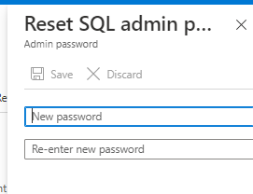

Don’t forget to pause the sql pool at the end

